METAGOL SPEC- Character Creation

## Overview

* The game has a character creation system which allows the players to create their customized playable avatars
* This spec will define the character creation systems and how the player can use it.

## Character Creator

* The players can name the character.
* The player can also choose the type of voice.
* The creator is divided into three panels.
* The left panel will show the parameters that can be customized. The middle panel will display the avatar and update as the changes are applied. The player can rotate their character 360 degrees using the arrows given in this panel. The right panel will show the options available when a particular parameter is being customized.
* Twelve parameters will be accessible to the players. Each parameter will have some predefined options that the player can select
  + Gender : Male/Female/Trans - This will affect how the player’s pronouns are addressed. Can be selected by using the gender icons.
  + Traits : The player can select upto three traits that can enhance gameplay. Each trait will have pros and cons. Eg. Animal Husbandry, Fish Farming, etc. Can be changed later by spending a high amount of diamonds.
  + Ethnicity : This will affect the ethnicity and the skin color.
  + Head Type : This will affect the shape of the character’s head.
  + Eye Shape and color: This will change the shape and color of the eyes.
  + Nose shape : Can change the shape of the nose
  + Mouth Shape : Changes the shape of the mouth and lips.
  + Hair style : Affects the styling of the hair and color. Can be changed and unlocked and purchased using diamonds.
  + Facial Hair : Changes the facial hairstyling and color. Can be changed and unlocked and purchased using diamonds.
  + Outfits: Changes the outfits. Predefined color combinations can be applied to the outfits.Can be changed and unlocked and purchased using diamonds.
  + Headdress : Changes hats, helmets, caps, etc. Can be changed and unlocked and purchased using diamonds.
  + Pet: This will add a pet that will give caregiving tasks to the player
* The character can be saved using the confirm button which takes you to the location screen.

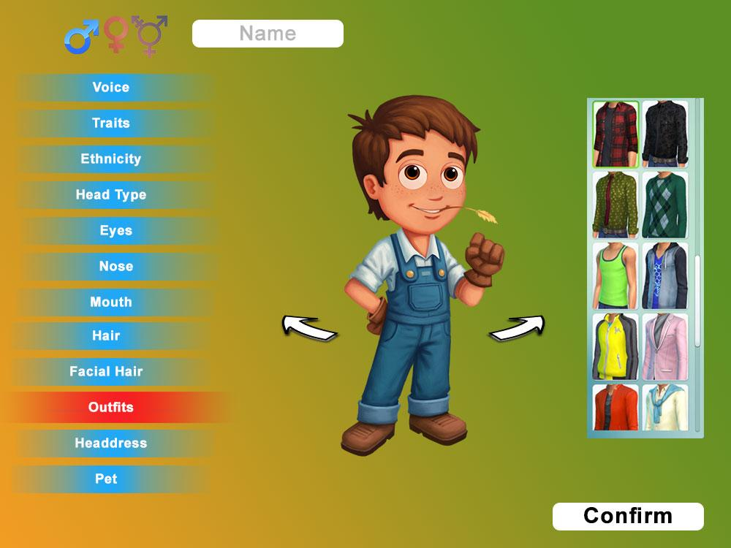

* Location : The player can select which part of the world does he want to farm in. Every region has its own crops, climates, animals etc with its own set of challenges and advantages.. It can be changed later on in the game but requires a huge amount of diamonds.